Study of the ultrafast trap of an aquatic carnivorous plant
Philippe Marmottant, Olivier Vincent and Catherine Quilliet,

Laboratoire de Spectrométrie Physique
CNRS / Université de Grenoble
140 av de la Physique 38042 Grenoble
marmotta@spectro.ujf-grenoble.fr

Abstract

A process difficult to perform within the channels of a miniaturized lab, called Lab on a chip, is the sudden transfer of a small sample of fluid in a closed container. This operation is naturally found in the vegetal kingdom when considering the aquatic carnivorous plants Utricularia (common name bladderwort). This plants are gifted with suction traps (Skotheim 2005): a contact opens a door, the trap sucks in liquid, and then the door closes hermetically, all this sequence within the impressive time of a few milliseconds, barely visible with the naked eye. We present an on-going experimental study of the biomechanics of the trap. The motion of the trap door is recorded by a high-speed camera. We could record the natural activation of the trap (using different fresh water crustaceans), and then provoke activation of the trap with a fine needle. With this artificial triggering, we could focus on the succession of the two distinct phases of the suction : first the door opens, and second the door closes hermetically after suction. The motion is therefore different from the close-only traps of the Venus flytrap (Forterre 2005). We also record the associated fluid motion. We find that the door is curved inwards at opening, and that an intense flow of liquid (1 m/s) is generated during a very short time (0.4 ms). These observations are interpreted with a biomechanical approach involving elasticity and flow. The door opening is described as a buckling of the door under a preexisting pressure, because of a softening of the door following the touch of sensitive trigger hairs. The door closure results from the equilibration of pressures, and from the fact that the relaxed shape of the door is the closed position. An original behavior was also recorded: after a few hours the trap activates spontaneously . If the precise biological function of this phenomenon is unclear, it expresses the fact that the sensibility of the plant increases considerably at time of 5 hours, and is trigger by very small fluctuations. We conclude by the presentation of a simple analytical model that will prove useful for the design of a biomimetic reproduction of the trap, and its implementation in a microfluidic circuit as a miniaturized pipette.

1. Introduction

1.1 Carnivorous plants

It exists more than 600 species of known carnivorous plants, resulting from a spectacular adaptation to difficult environmental conditions (lack of nutriments or poor lightning, Juniper 1989). These plants present different kind of traps to catch animals. It is possible to classify these traps into two groups:
- Passive traps, where the plant is immobile, such as the one from the Nepenthes (fig. 1a)
- Active traps, such as the one from the Dionea (fig 1b).

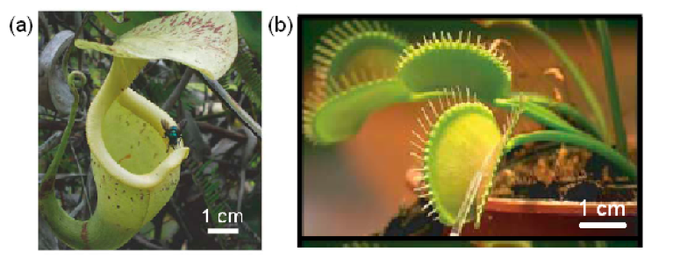

Figure 1: Two kinds of carnivorous plants (a) Nepenthes with a passive trap (taken from Gaume 2007), (b) Dionea with an active trap (taken from Forterre 2005).

A complementary approach between physicists and biologists has recently helped to elucidate the mechanisms of certain traps, such as the use of an elastic instability to maximize the speed of capture with the Dionea (Forterre 2005) or the presence of a visco-elastic fluid in the receptacle of the Nepenthes (Gaume 2007).

1.2 Bladderwort (Utricularia)

The bladderworts are a type of aquatic carnivorous plant that regroups 180 species, including the one we study, Utricularia inflata. Numerous biologists have contributed to their description, and to the explanation of their mechanism. First studied in the 19th century, their carnivorous character has been discovered in 1876 (Treat 1876). A first detailed study is due to Lloyd (1942), who described the plant constitution and proposed an electromechanical analogy to describe its behaviour. This model was later abandoned by the author himself, because of its extreme complexity.

The plant consists in a long stem, from which ramifications are attached, and where the traps are situated. The traps, sometimes called utricules have a size of the order of 1mm.

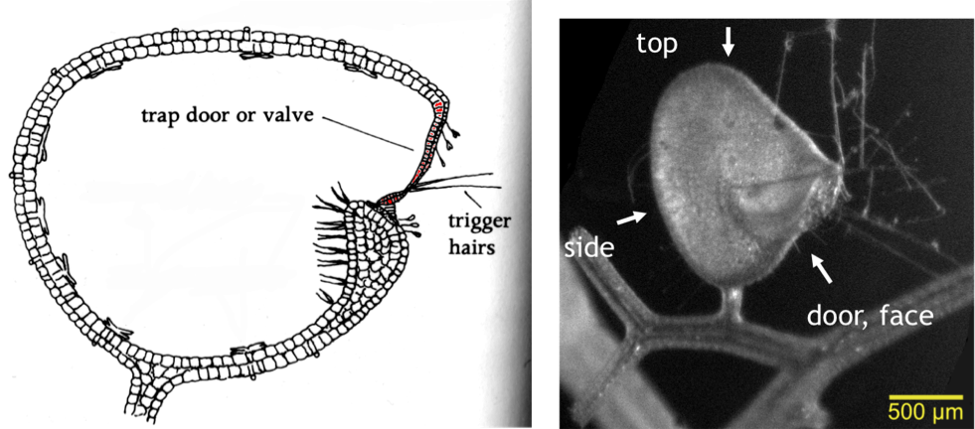
(a) (b)
Figure 2 – Description of the trap of the Utricularia (a) Cutview of the trap, taken from Juniper 1989, (b) The three main view of the trap.

It is possible to distinguish two main parts:
- the wall, made of only two layers of cells. Its thickness is sensibly constant all over the surface (we measured 60 micrometers), and increases near the door to form a quasi-circular (ring) rigid structure, whose bottom part is called the threshold.
- the door is attached to the upper part of this ring. The bottom part is in compression against a threshold called the velum whose role is to avoid any leaks when the door is closed. The door is also composed of only two cell layers, thinner than in the wall. The precise structure is complex. Several trigger hairs are located on the door wall, and are responsible for the triggering of the door. The thickness of the door is around 15 micrometers.

1.3 Summary of the literature on the trap mechanism

We now sum up a few results that are generally admitted concerning the trap mechanism of the bladderwort.

Trap setting The plant is able to pump water from the inside to the outside of the trap, probably through the action of glands situated in the wall (bifide and quadrifide glands, see Sasago 1985). The utricle is waterproof, and this deflates the trap, with a depression of the water inside as low as 0.17 bars. The time need to set the trap varies from 30 minutes to 4 hours. The plants resist the pressure thanks to its reaction on the velum (Lloyd 1929).

Trap activation When a prey approaches the trap, it can trigger the trap by touching one of the sensitive hairs situated at the bottom of the door, which provokes its aperture and the suction of the water, the prey included. The door then closes back, which impedes the prey from escaping and renders the utricle waterproof again. The capture time is evaluated to be 30 milliseconds approximately (Lloyd 1942, Sydenham 1973). The door opening and closing mechanism remains poorly understood, and two main hypothesis are generally put forward:
- Mechanical hypothesis: the trigger hairs act as levers, and un-block the door, which provokes the entrance of water, until the pressures are established again (Heide-Jorgensen 1981). We showed that this hypothesis remains un-probable in view of our observations.
- Active hypothesis: touching the hair triggers a stimulus that propagates in neighbouring cells, and provokes a softening of the door, that is therefore not able to resist the applied pressure anymore (Stuhlman 1950). Measurements have shown a change of electrical potential (Sydenham 1975), which would corroborate this hypothesis.
The originality and complexity of the trap arise from the fact that, contrary to the other carnivorous plants that have only a closing phase, the bladderwort are able to open and close in a fraction of a second.

The comprehension of the trap triggering is limited by several aspects: the observation of ultra-fast phenomena, and a modelisation of the physical phenomena at play.

2. Methods

Plants were cultivated indoors, in deionized water, in order to reproduce their natural inhabitat. Traps were placed in a Petri dish and were observed under the microscope (up to 10x).

The dynamics of the trap were studied with two kinds of imaging techniques:
- time-lapse, with a ‘slow’ camera operated at 1 frame every 100s (0.01 Hz)
- high-speed, with a camera that could operate up to 8000 frames per seconds (8000 Hz).
Image analysis was performed with ImageJ (freeware) and Matlab (Mathworks, Inc.).

A more detailed study can be read in the master thesis by Olivier Vincent (in french).

3. Results

We present results obtained from the analysis of image sequences, for the two phases of the trap.

3.1 Trap setting

Seen from the top, it is convenient to evaluate the volume diminution of the trap measured by its thickness e, at the waist of the trap profile (figure 3). The shape evolves with time, with an exponential decrease of the thickness (figure 4), with a characteristic time of 52 minutes.

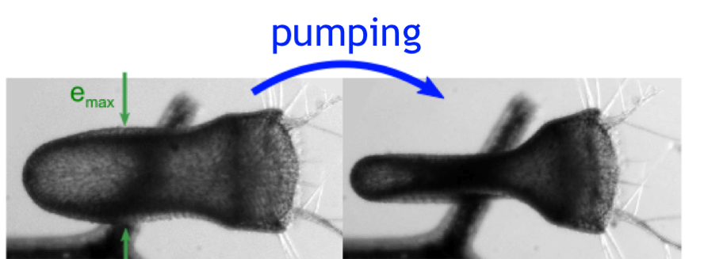
Figure 3: evolution of the trap profile, monitored by the thickness e.

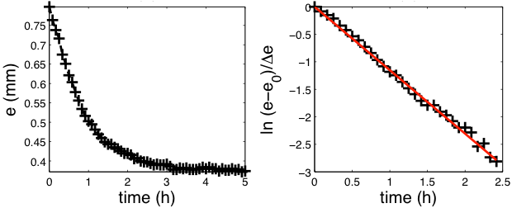
Figure 4: exponential decrease of the thickness, represented in linear units (left) and in logarithmic units (right).

3.2 Trap suction

The door is activated manually with the tip of a needle, by touching one of the sensitive hairs. We could show that a very small bending of the trigger hair is enough to trigger the response. The duration of the suction is extremely short: around 2 ms, see figure 5.
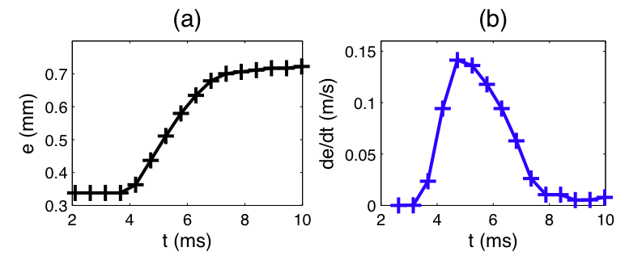
Figure 5: fast inflation of the plant after trap activation.

The aspiration is monitored using tracer particles (hollow glass beads), placed near the door. The maximum fluid velocity measured is extremely high: 1.5 m/s at the largest.

We distinguish two zones:
- an aspiration zone, where the particles, followed during their motion are completely trapped (red particles on figure 6),
- the outer zone, where particles are moved by the suction, but do not enter (black particles on figure 6).
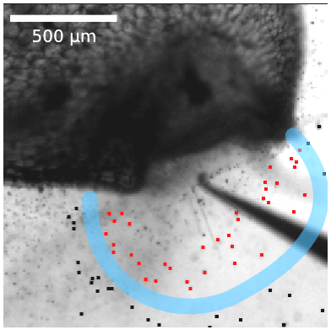
Figure 6: aspiration zone.
Moreover, the examination of the sequence of images reveals that the door closes completely after a short time (estimated as 20 ms).

4. Conclusion and perspectives

A low-speed and high-speed video study revealed the huge dissymmetry of time scales at play during the trap setting and activation. The trap setting can be interpreted as a storage of elastic energy, and is similar to the bending of an arc.

The release of the energy is violent and occurs with a few milliseconds, suggesting large amplitude bifurcation of the behaviour, triggered by touching the hair. We could confirm that the species Utricularia inflata, has an active mechanism, since a slight touch, not enough to create a lever effect, was at the origin of the trap triggering.

The door opens and closes in a very short time interval of around 20 ms: we are currently undertaking detailed experiments of the phases of the door opening. In our presentation we will play high-speed recordings, that help see the succession of the door opening and closing.

The spontaneous activation of the trap was also recorded. In our presentation, we will show that even in the absence of manual trigger, small fluctuations (from instance from tiny swimming paramecium present in the medium, or maybe just thermal fluctuations) were enough to trigger the trap, on average after 5 hours.

As a perspective, this work is also at the source of a biomimetical inspiration to design a miniature suction apparatus, helpful to isolate very small quantities of liquid. This biomimetical design would find its place within the realm of Lab-on-chip devices, that need to treat very small amounts of liquid.

References

Forterre, Y, Jan M. Skotheim, Jacques Dumais, and L. Mahadevan. How the venus ﬂytrap snaps. Nature, 433(7024) :421–425, January 2005.
Gaume, Laurence and Yoel Forterre. A viscoelastic deadly ﬂuid in carnivorous pitcher plants. PLoS One, 2007.

Heide-Jorgensen, H.S., Parasitisme og carnivoi. Kompedium, Institut for Planteanatomi og Cytologi, Kobenhavns Universitet, 1981.
Juniper, B.E., R. J. Robins, and D. M. Joel. The carnivorous plants. Academic Press, 1989.

Lloyd, F.E., The mechanism of the water tight door of the utricularia trap. Plant Physiol., 4(1) :87–102, Jan 1929.
Lloyd, F.E., The carnivorous plants. Chronica Botanica Company, 1942.

Sasago, A., and Takao Sibaoka. Water extrusion in the trap bladders of utricularia vulgaris i. a possible pathway of water across the bladder wall. Bot. Mat. Tokyo, 98 :55–66, 1985.
Skotheim, J.M. and L. Mahadevan. Physical limits and design principles for plant and fungal movements. Science, 308(5726) :1308–1310, 2005.
Stuhlman, O Jr and E. B. Darder. The action potentials obtained from venus’s-ﬂytrap. Science, 111 :491–492, 1950.
Sydenham, P.H. and G. P. Findlay. The rapid movement of the bladder of utricularia sp. Aust. J. biol. Sci., 26 :1115–1126, 1973.
Sydenham, P.H and G.P Findlay. Transport of solutes and water by resetting bladders of utricularia. Functional Plant Biol., 2(3) :335–351, January 1975.
Vincent, O., Une approche physique du fonctionnement du piège d’une plante carnivore aquatique: l’Utriculaire, Master thesis, University of Grenoble I, 2009.
Treat. M. Is the valve of utricularia sensitive ? Harper’s New Monthly Magazine, 52 :382–387, 1876.

